Semester 1 CCNA

**Chapter 1 – Explore the Network**

* OSI Model – Open Systems Interconnection [SEE PICTURE IN NOTEBOOK]
  + Please Do Not Throw Sausage Pizza Away ( 1 🡪 7)
* Peer-to-Peer – devices act as both clients and servers, easy simple and low cost
  + Not scalable, less secure, slow performance, no central admin
* Converged network – all forms of data travel on the same network (voice, video, data)
* Wireless Broadband – Cell towers and antennae to access internet (like cell phones)

Network Representations:

* End Device – Source or destination of data
* Intermediary Devices – router, switch, firewall appliance all use destination end device address and properties of the network to determine path of data
* Network media
  + Metallic wires within cables – data encoded in electrical impulses
  + Fiberoptic cable – fast, pulses of light, for long distance
  + Wireless – E/M spectrum, fast but short distance
* Network Interface Card (NIC) – provides physical connection to the network at PC
* Physical Port – connector on networking device that connects media to end device
* Interface – Specialized ports that connect to individual networks (ports on a router)

Types of Networks:

* Local Area Network (LAN) – small geographical area managed by individuals or companies, fast and high bandwidth
* Wide Area Network (WAN) – large geographical area managed by service providers
* Wireless LAN (WLAN) – same as LAN but connects using wireless means
* 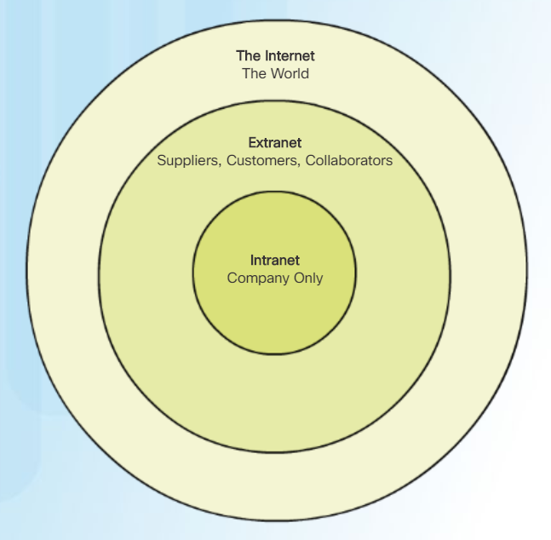Storage Area Network (SAN) – supports file servers, data storage, retrieval and replication

Connections:

* Cable – high bandwidth, always on, and connection to internet via TV providers
* DSL – Digital Subscriber Lines – high bandwidth, always on, internet connection via telephone lines
* Cellular – uses cellphone network to connect, limited capabilities and needs cell tower
* Satellite – need satellite dishes with clear line of sight but provides internet to desolate places that otherwise wouldn’t have any
* Dial-up Telephone – cheap phone line modem, low bandwidth but useful while traveling
* Dedicated Leased Line – businesses rent private network lines between locations
* Ethernet WAN – extend LAN to WAN

Network Architecture:

* Fault Tolerance – how it rebounds from mistakes
* Scalability – ability to add users
* Security – protecting packets of information
  + Confidentiality – only intended recipients are authorized to view it
  + Integrity – data has not been altered
  + Availability – timely and reliable delivery
* Quality of Service (QoS) – speed and accuracy

New Trends

* Bring Your Own Device (BYOD) – connect personal devices to network
* Online Collaboration – ability to work on projects across the network
* Video Communication – teleconferences and skype
* Cloud computing – using someone else’s processers
* Powerline Networking – plug PL into wall outlet, connects all devices to network

**Chapter 2 – Configuring a Network Operating System**

* Operating Systems
  + Shell – what he user typically interacts with
  + Kernel – communicates between the hardware and software, managing hardware
  + Hardware – physical part with electronics
* Access Methods
  + Console – plugging in via hard wire
  + SSH – *secure* remote connection through virtual interface over a network
  + Telnet – *insecure* remote connection through virtual interface over a network
* Primary Command Modes
  + User Exec Mode – Switch>/Router> limited number of basic commands
  + Privileged EXEC Mode – Switch#/Router# can use all commands
* Configuration Command Modes
  + Line Configuration Mode – used to configure console, SSH, Telnet, or AUX access
  + 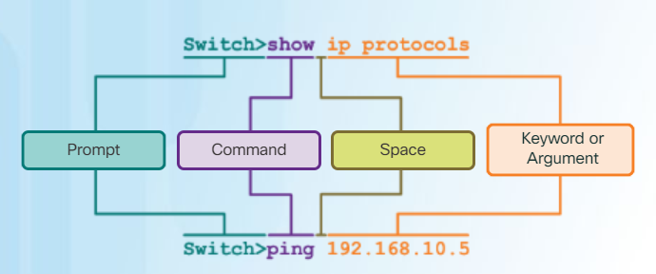Interface Configuration Mode – Used to configure a switch port or router network interface

Commands to Configure a Switch:

Switch>enable

Switch#configure terminal

Switch(config)#hostname [name here]

[name](config)#line con 0

[name](config-line)#password cisco

[name](config-line)#login

[name](config-line)#logging synchronous

[name](config-line)#line vty 0 15

[name](config-line)#password cisco

[name](config-line)#login

[name](config-line)#transport input ssh telnet

[name](config-line)#exit

[name](config-vlan)#int vlan 1

[name](config-if)# ip address 192.168.10.1 255.255.255.0

Other Commands

exit – backs up one space

end – backs out of config

do show run – shows what you’ve done

Subnetting:

|  |  |  |  |  |  |  |  |
| --- | --- | --- | --- | --- | --- | --- | --- |
| Host Requirement | INC | Net ID | 1st Use | Last Use | Broadcast | CSM | CIDR |
| # of IP addresses needed | Increment of IPv4 | Starting IP | Net ID +1 | Broadcast -1 | Last available (next Net ID -1) | Max # per space | # of 1s in max |
| **157** | 1.0 | **10.0.0.0** | 10.0.0.1 | 10.0.0.254 | 10.0.0.255 | 255.255.255.0 | /24 |
| **136** | 1.0 | 10.0.1.0 | 10.0.1.1 | 10.0.1.254 | 10.0.1.255 | 255.255.255.0 | /24 |
| **71** | .128 | 10.0.2.0 | 10.0.2.1 | 10.0.2.126 | 10.0.2.127 | 255.255.255.128 | /25 |
| **4** | .8 | 10.0.2.128 | 10.0.2.129 | 10.0.2.134 | 10.0.2.135 | 255.255.255.248 | /29 |
|  |  | 10.0.2.136 |  |  |  |  |  |

|  |  |  |  |  |  |  |  |  |  |  |  |  |  |  |  |  |  |  |  |  |  |  |  |  |  |  |  |  |  |  |  |
| --- | --- | --- | --- | --- | --- | --- | --- | --- | --- | --- | --- | --- | --- | --- | --- | --- | --- | --- | --- | --- | --- | --- | --- | --- | --- | --- | --- | --- | --- | --- | --- |
| 1 | 6 | 3 | 1 | 8 | 4 | 2 | 1 | 1 | 6 | 3 | 1 | 8 | 4 | 2 | 1 | 1 | 6 | 3 | 1 | 8 | 4 | 2 | 1 | 1 | 6 | 3 | 1 | 8 | 4 | 2 | 1 |
| 2 | 4 | 2 | 6 |  |  |  |  | 2 | 4 | 2 | 6 |  |  |  |  | 2 | 4 | 2 | 6 |  |  |  |  | 2 | 4 | 2 | 6 |  |  |  |  |
| 8 |  |  |  |  |  |  |  | 8 |  |  |  |  |  |  |  | 8 |  |  |  |  |  |  |  | 8 |  |  |  |  |  |  |  |

|  |  |  |  |  |  |  |  |  |  |  |  |  |  |  |  |
| --- | --- | --- | --- | --- | --- | --- | --- | --- | --- | --- | --- | --- | --- | --- | --- |
| **2^** | 0 | 1 | 2 | 3 | 4 | 5 | 6 | 7 | 8 | 9 | 10 | 11 | 12 | 13 | 14 |
| **=** | 1 | 2 | 4 | 8 | 16 | 32 | 64 | 256 | 512 | 1024 | 2048 | 4096 | 8192 | 16384 | 32768 |